# CA2 REPORT

A0279734M LI XINRUI

This assignment aims to solve a fishery problem with a branch of uncertain data by MCMC model.

First is to determine the estimation of unknown parameter r and K. This step is mainly about optimization with the calculated loss between estimation and the given true value. The input H is a scalar number while p0 is uncertain. The package”Measurements” is used to construct the data structure with uncertainty. The initial guess of r and K is 1.5e-5 ± 5.7e-8 and 2.8e5 ± 760, respectively. The ODE problem is built and the loss is summed by 5 pairs of input p0 and H.

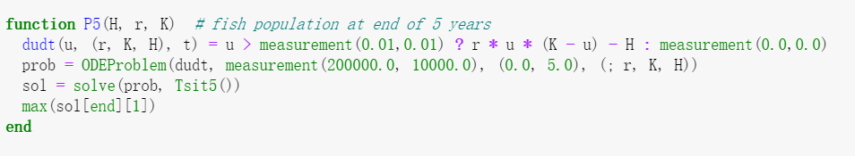

Then, the “Optim” library is used to solve the optimization problem.



By solving the optimization problem, the optimized r and K are calculated with uncertainty:

r = 8.992e-6 ± 3.5e-8

K= 278000.0 ± 1000.0

The next step is to estimate H by the above parameters.

Use the above optimal parameters, the normal distribution of r, K and P0 are generated, then a random value is selected from the distribution set. H is initialized to be 140000. A loop containing 2000 iterations with the same input H is constructed to run several times for different random r, K and P0, getting the result for ODE problem, and the values are saved in a solution array, compared with the threshold 100000. For the 90% confidence level, I calculate the number of solution values that below the threshold, if the number of value is less than 200, that is less than 10% of the results not fulfill the requirement, the decrease of H by 500 is conducted. Updated H returns to the loop again and do the new calculation by randomly selected parameters and count the number of solutions that below 100000, until the proportion is more than 10%.

The flow for the algorithm is shown as below:

1. Set up Normal distribution for r, K, P0, initialize H
2. Start loop:
   1. Randomly select r, K, P0 from the distribution
   2. Solve ODE problem and save the solution value
3. Count the number of values that below the threshold 100000
4. If the counting proportion is less than 10% of total solutions:Decrease H by 500, return to step 2; otherwise, end the process and get the maximal H.

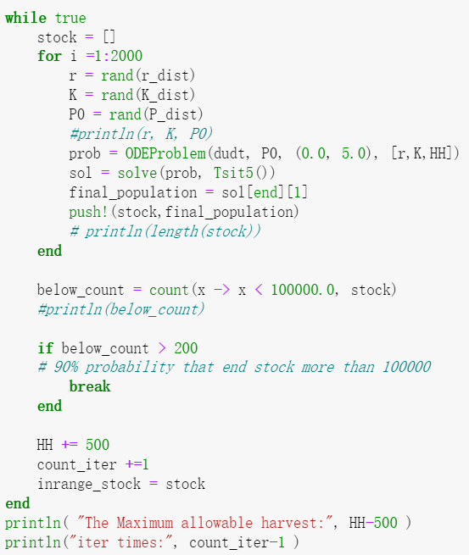

The maximum H result is 185500.0

The distribution for the stock at the end of 5 years with maximum H is visualized as below:

